TITLE

F. FamilyName¹ and F. FamilyName ²

¹Affiliation 1
²Affiliation 2

The abstracts are limited to ONE page, including text and figures. The Abstract templates are available online in several formats. The template shall be completed and submitted in pdf format on the conference website: https://quantumlight-2d.sciencesconf.org. Thank you for submitting your abstract !

References
[1] A. Einstein, B. Podolsky, and N. Rosen. Can Quantum-Mechanical Description of Physical Reality Be Considered Complete? Phys. Rev. 47, 777. 1935
[2] M. Kuwabara, D. R. Clarke, and D. A. Smith. Anomalous superperiodicity in scanning tunneling microscope images of graphite. APL. 56, 2396. 1990

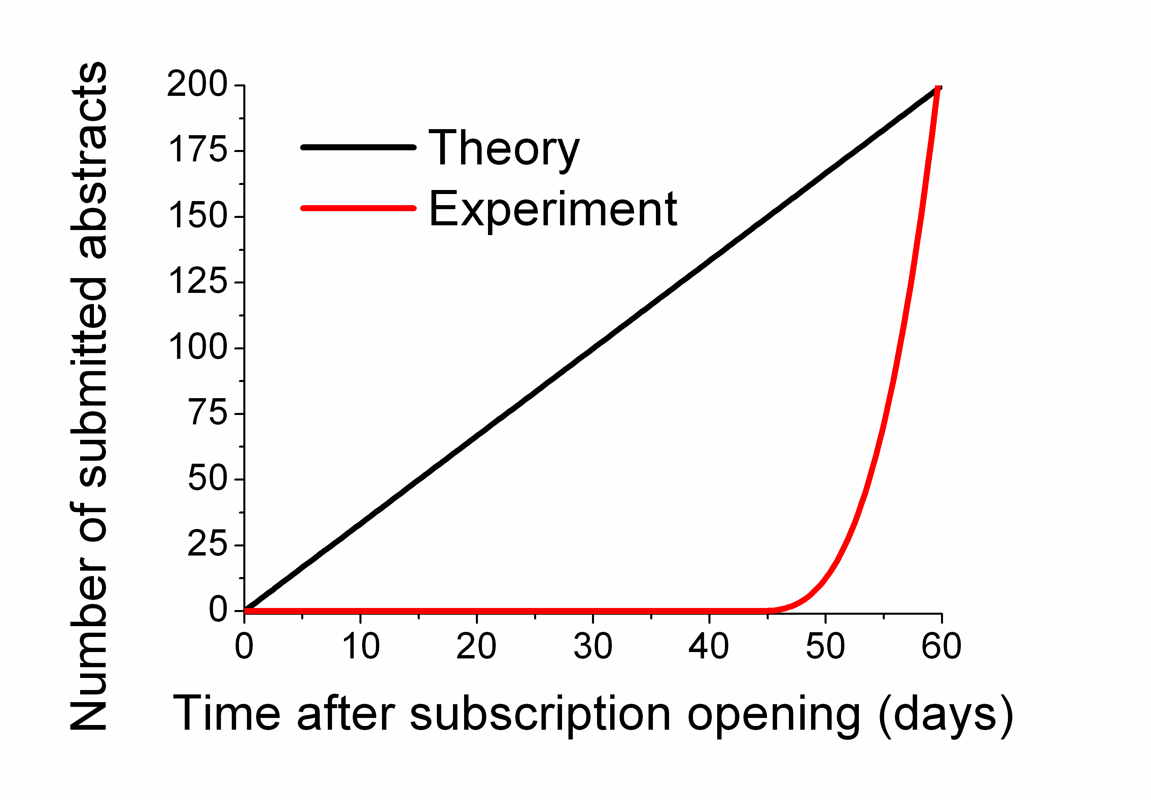

Figure 1: Conference logo.
Figure 2: Number of submitted abstracts versus time: theory in black and experimental values in red.

